**­­Work in progress, just started…**

GUI windows

1. Command window  
   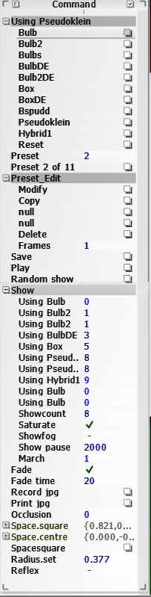
   1. Using Group  
      To elect a shader, load and runs the last saved set of parameters
   2. Preset  
      Move across saved parameter set of the current shader
   3. Preset n of m  
      Reload the current. Similar to reset of the current shader.
   4. Preset Edit Group
      1. Modify  
         Update the local parameters (doesn’t update the parameters set on disk)
      2. Copy  
         Select the local parameters (doesn’t update the parameters set on disk)
      3. Paste  
         Pastes the copied parameter set on the current one
      4. Insert  
         Insert the copied parameter set after the current one
      5. Delete  
         Delete the current parameter set
      6. Frames  
         Number of frames between current and next parameter set (when playing active)
   5. Save  
      Save to disk the current modified set and set it as starting point at load
   6. Play  
      Runs through the Preset parameters. If Frames isn’t set to zero tries to interpolate between a parameters set and the next one. Can stop playing pressing the space bar.
   7. Random Show  
      Generates random fractals. Can stop the show pressing the space bar.  
      Pressing T Key hides the GUI.
   8. Show Group
      1. Using  
         Select the shader to be shown (Only Bulb, Box, Pseudoklein and Hybrid1 currently supported).  
         Up to ten shaders can be shown randomly through
      2. Showcount  
         If a shader is repeated it will statistically show up more frequently
      3. Saturate  
         Colors are chosen randomly, saturated if active.
      4. Showfog  
         Random fog level enable
      5. Showpause  
         Pause in milliseconds between random frames
      6. March  
         If greater than one each random frame will be zoomed in before showing a new one
   9. Fade  
      Enable/disable fading between frames when Play or Random Show are active
   10. Fade time  
       Not a fixed time, depends on the processor speed
   11. Record jpg  
       When active will print a .jpg for each frame during Play and Random show.  
       File name and directory are printed to the console window
   12. Print jpg  
       Print a jpg of the current window.   
       File name and directory are printed to the console window
   13. Occlusion  
       Currently non supported
   14. Space.square  
       Defines a cubic box. Fractal is explored only inside the box, what’s out Is cut off.
   15. Space.centre  
       Centre of the Space.square box
   16. Spacesquare  
       Toggle between cubic and spherical box
   17. Radius.set  
       Radius of the spherical box
   18. Reflex  
       Renders reflections (implemented experimentally on Pseudoklenian only )
2. Navigation windows (Rotate / Translate at the upper right corner of the GUI)  
   Mouse wheel toggles navigation mode.  
   When the “Rotate” or “Translate” window are displayed, click o the fractal and drag the mouse to rotate or translate the view.  
   Left, right, left+right mouse buttons rotate or move around different axes.  
   When axes display is enabled, pressing a mouse button highlights the selected axe.  
   To rotate, keep the mouse button down and move it until the cursor exits the round finder (similar the Rotoslider of the AntTweakbar)  
     
   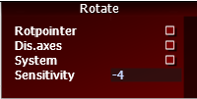 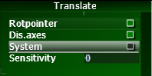  
   1. Rotation center, toggles between  
      Rotcenter rotates the fractal at the system center coordinates. It’s the preferred rotation center when the whole fractal is displayed.   
      Rotpointer finds the point of the surface at the mouse pointer and uses it as the rotation center. It’s the preferred rotation center when zooming close to the fractal surface and the fractal center is far way. The mouse must be positioned on the fractal surface; if it’s positioned on the background the last Rotpointer will be used.
   2. Disp.axes   
      Toggles navigation axes on/off. Axes are displayed only when a mouse button is pressed
   3. Rotation and translation axes, toggles between   
      System axes  
      Fractal axes   
      Axes are visible when a mouse button is pressed
   4. Speed   
      Sensitivity of the mouse (Rotate and Translate have separate Speed settings
3. Palette window  
     
   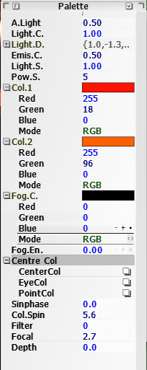  
   1. A.light, Light.C, Lighr.D, Emiss.C, Light.S, Pow.S  
      refer to the standard Phong shading technique (more or less)
   2. Col.1 and Col.2  
      The rendered color is a mix of the two colors
   3. Fog.C  
      Fog color (when enabled) and color of the background (when fog is disabled)
   4. Fog.En  
      When set to zero disables fog display, otherwise defines fog intensity
   5. Center.Col  
      The color mixed is based upon the distance from :
      1. CenterCol (the system origin)
      2. EyeCol (the current camera)
      3. PointCol (a point on surface selected clicking on the fractal image)
   6. Sinphase  
      Color are mixed as a function of the sine of the distance.  
      The button set the stating phase of the sine
   7. Col.Spin  
      Sine frequency, determines how fast the colors change
   8. Filter  
      When greater than zero activate a 2D blur filter
   9. Focal   
      is the distance from the camera at which the blur filter isn’t active. Image is blurred moving away from the focal point
   10. Depth  
       Depth of the blur filter. The three parameters aim to simulate a camera (focus and field depth)
4. Parameter window (active for Mandelbulb and Mandelbox fractal types)  
     
   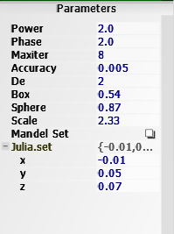  
   1. Power and Phase  
      Power and phase of the Mandelbulb fractals
   2. Maxiter  
      Bailout iterations for brute force method
   3. Accuracy  
      Ray trace step resolution
   4. De  
      Distance estimation bailout (kind of arbitrary units, affects accuracy)
   5. Box, Sphere and Scale  
      Standard parameters of Mandelbox type of fractal
   6. Mandel Set  
      Toggles between Mandebub and Julia set
   7. Julia.set  
      Coordinates of the Julia constant
5. Hybrid param window  
   Parameter window for fractals other than Mandelbulb and Mandelbox.  
   Currently all mixed up, need time to put some order and meaningful labels
6. Debug window  
     
   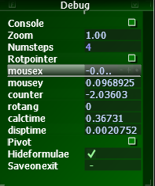  
     
   Mostly used to help debugging shaders.  
   Some of it may also be useful for standard navigation, such as:
   1. Console  
      Toggles on/off the console window keeping track of disk I7O activity and some debug and warning messages
   2. Zoom  
      Changes the FOV of the ray tracer.  
      Similar to moving the camera in and out in Translate navigation mode.  
      Mostly used by the Random Show function (see Command window)
   3. Numsteps  
      Clicking and dragging the mouse drop the resolution of the fractal to reduce the time needed to refresh the image and make the navigation faster.  
      When set to 4, renders one pixel of the window out of 4.  
      When set to 8 …
   4. Pivot  
      When set rotates the camera instead of rotating the fractal.  
      Navigation must be set to Rotate mode.  
      Need to work on it to make it more usable.
   5. Hideformulae  
      When set automatically closes the list of Formulae in the Command window after the selection of a formula
   6. Saveonexit  
      Save everything when the program is closed (either closing the main window, or the console window or pressing the Escape k).  
      The next run will start from saved status.  
      The status can be saved manually pressing the Save button in the Command window.

Some hints: how to navigate.

To move across the fractal just use mouse wheel, mouse, and mouse button.  
Mouse wheel toggles between Translate and Rotate modes.

In Translate mode just click on the fractal and move the mouse right to left or up and down.  
Left and right buttons select the direction of the translation (right/left, up/down, in/out Figures 1,2,3).  
Initially up/down and in/out were combined together; I later decided to keep them separate, even if initially somehow counterintuitive, because navigation can be better controlled, especially when navigating close to the fractal surface. Of course it could be turned back to the original combined movement.  
Translation occurs in the direction of the System reference axes or to the Fractal axes:  
Fractal axes rotates with the fractal and the Translation direction changes accordingly (Figures 4, 5)

In Rotate mode clicking on the fractal display a circle and a crosshair.  
Keeping the button pressed, nothing moves until the cursor goes outside the crosshair; once there, the fractal rotates with the cursor.  
Like in Translation mode, rotation axes can be toggled between System and Fractal and specific axes is selected by the mouse buttons. Both Translate and Rotate modes highlight the rotating axe changing the color from write to red or green.  
In translate mode the rotation centre selected in the Rotate window between Rotcentre and Rotpointer (Figure 4 and 5).  
When Rotcentre is selected the rotation occurs around the selected axe at the system origin.  
When Rotpointer is selected the rotation pointer is moved to the point of the surface of the fractal selected by the mouse. The mouse must be hovering the fractal, not the background; if not the rotation takes place around the last valid selected rotation point.

In general Rotpointer mode is preferable when zooming in close to the fractal, when the system centre is far away and it’s difficult to understand how the actual rotation will take place.  
Rotcentre is preferable when the whole fractal is visible.

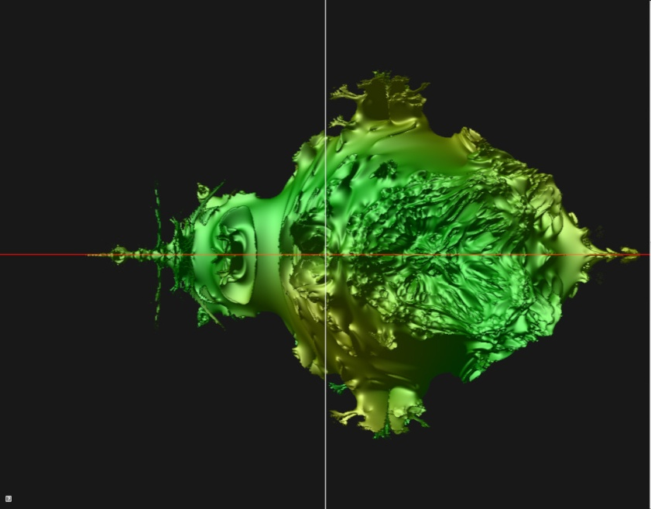

1 Translate mode, System Axes, Right button, move right

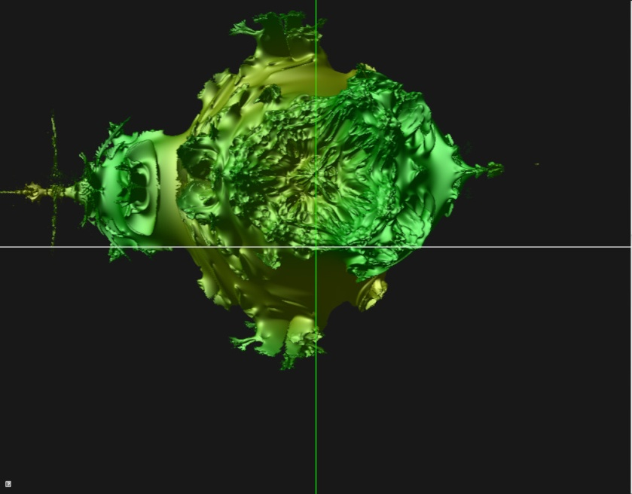

2 Translate mode, System Axes, Left button, move up

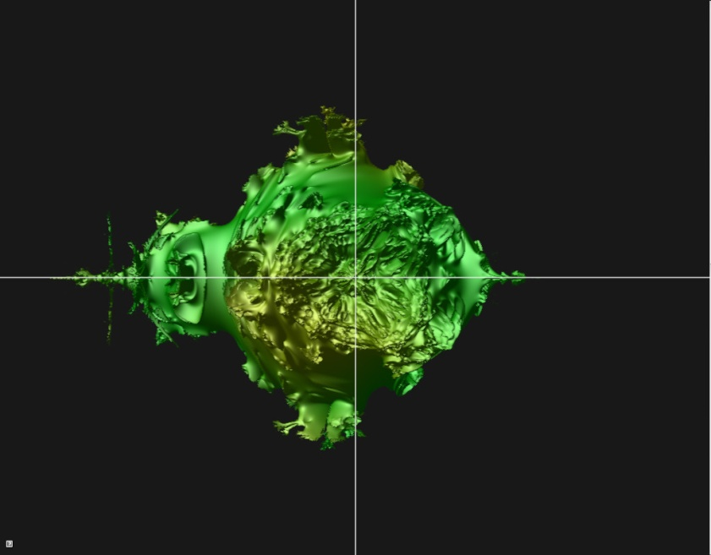

3 Translate mode, System Axes ,Both buttons, move in

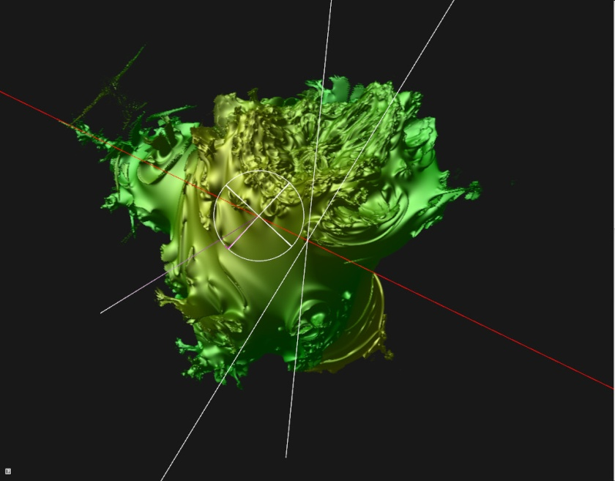

4 Rotate mode, Rotcentre, Fractal axes (Red axes selected)

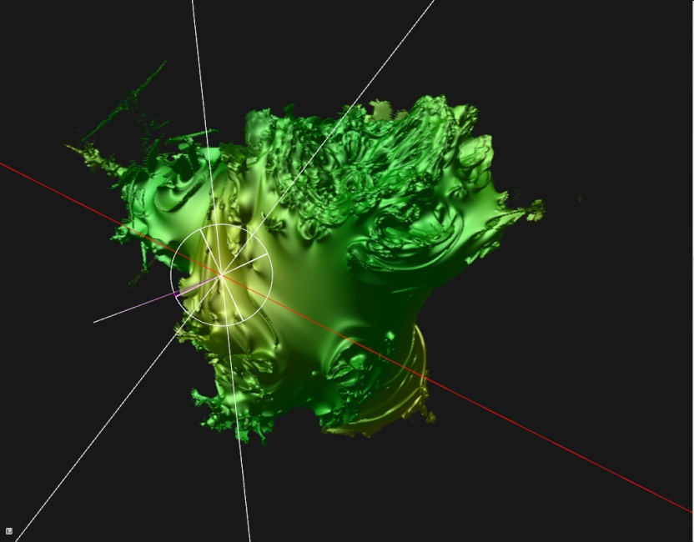

Rotate mode, Rotpointer, Fractal axes